**Aim:** Design FIR filter with windowing method.

**Theory:-**

* The windowing method is a commonly used technique for designing FIR filters. It involves designing an ideal frequency response and then applying a window function to obtain a practical FIR filter.
* The steps involved in designing an FIR filter using the windowing method are as follows:
* Specify the desired filter specifications, such as the cutoff frequency, filter length, and window type.
* Design an ideal frequency response that meets the desired specifications.
* Apply a window function to the ideal frequency response to obtain the filter coefficients.
* Normalize the filter coefficients to ensure stability.
* There are various window functions available, such as the rectangular, Bartlett, Hann, Hamming, and Blackman windows, among others. The choice of window function depends on the desired trade-off between the main lobe width and sidelobe suppression.

**Programm:-**

import matplotlib.pyplot as plt

import numpy as np

from scipy.signal import firwin, freqz

*# Filter parameters*

cutoff_frequency = 0.2  *# Normalized cutoff frequency (0.0 to 0.5)*

filter_length = 31  *# Number of filter taps (odd for symmetry)*

*# Design the FIR filter using Hanning window method*

filter_coefficients = firwin(filter_length, *cutoff*=cutoff_frequency, *window*="hann")

*# Plot the impulse response of the filter*

plt.figure(*figsize*=(10, 5))

*# Impulse response*

plt.subplot(2, 1, 1)

plt.stem(filter_coefficients, *use_line_collection*=True)

plt.title("Impulse Response")

plt.xlabel("Sample")

plt.ylabel("Amplitude")

*# Frequency response*

plt.subplot(2, 1, 2)

frequencies, response = freqz(filter_coefficients)

plt.plot(frequencies, 20 * np.log10(np.abs(response)))

plt.title("Frequency Response")

plt.xlabel("Frequency (Hz)")

plt.ylabel("Magnitude (dB)")

plt.grid(True)

*# Final layout and display*

plt.tight_layout()

plt.show()

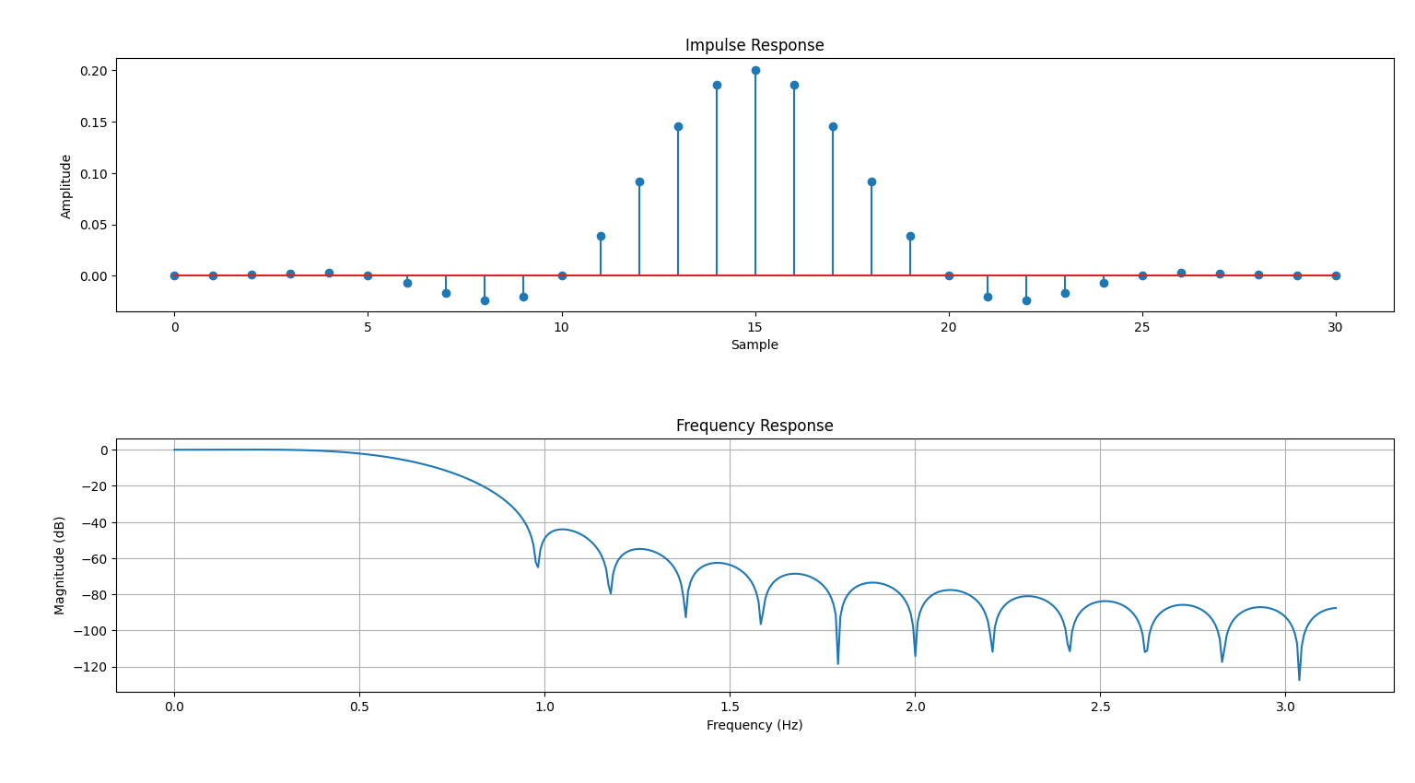**Output :-**

**Filter Coefficients :-**

5.621724098249910630e-03,-2.248408570661841743e-02,3.372191305732654548e-02,-2.247846538775357186e-02,5.618913938795535787e-03

1.000000000000000000e+00,-4.000320181991981805e+00,6.000960591637167774e+00,-4.000960637301628431e+00,1.000320227656443350e+00